**Engr 304 – Software Lab 4 Answer Template**

**Name: ___________________________**

**Section: ___________________________**

**Part I:**

**Insert your code for calculating the SumArray here, using proper formatting.**

/***********************************************************************************************/

/* Name: Daniel Ackuaku */

/* Course: Engineering 304L */

/* Lab: Lab Number 4 */

/* Date: 28th February 2019. */

/***********************************************************************************************/

/* The ".include nios_macros.s" assembler directive includes NIOS macros for use in the program */

.include "nios_macros.s"

/* The word-aligned address of the reset vector, value is taken from the

cpu configuration in SOPC builder. */

/*TEMPLATE: replace 0x00 with the appropriate address */

.equ RESET_VECTOR, 0x00

/* The ".text" assemlber directive indicates the beginning of the code section of the program */

.text

/* The ".org RESET_VECTOR" assembler directive places the main routine at the reset address */

.org RESET_VECTOR

/* The ".global _start" assembler directive exports the "_start" label as an external symbol */

.global _start

/* The "_start" label identifies the program start location for the debugger */

_start:

/*******************/

/**** MAIN ****/

/*******************/

/* Pseudo-code for this program is as follows */

/* Initialize variables (sum), initialize registers, etc

Begin LOOP

Read value from array

If value=0, exit the loop, else

Add value to sum variable

Increment loop index (or pointer address)

return to "Begin LOOP"

*/

/**** init ****/

MAIN_PROG_INIT:

movia gp, SumArray

movia sp, 0xffff /*ffff/* load the address of the array into the gp register */

movi r17, 50

mov r4, r0 /* clear register 8 for the sum */

/**** run ****/

MAIN_PROG:

beq r17, r4, MAIN_PROG_END

call SumCalc

addi r4, r4, 1

stw r2, 0(gp)

addi gp, gp, 4

br MAIN_PROG

/**** destroy ****/

MAIN_PROG_END:

br MAIN_PROG_END /* infinite loop to keep program from going into the weeds */

/*******************/

/**** DATA ****/

/*******************/

/* The ".data" directive identifies the section of the program that defines global variables */

.data

/* The "SumArray" label has an address equal to the address of the first element in the

array of words immediately following the label, this program uses it as arbitrary

zero-terminated example content to sum in the main program. */

SumArray:

.skip 50*4

/* The ".end" assembler directive indicates the end of the program and

all following lines are discarded */

.end

/*************************************************************************************************************/

**Insert your screenshot showing your array in memory in decimal format**

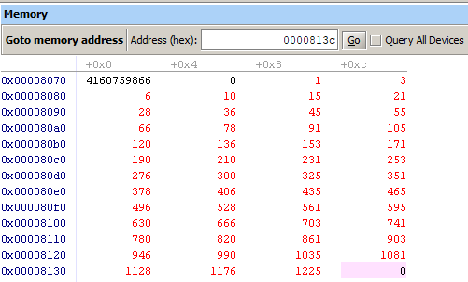

**Part II:**

**Provide your equations for stack space and for code/global space here, providing explanations for how you arrived at the equations.**

1. 3 items are pushed on the stack each time SumCalc is called.
2. Each new number takes up 12 bytes in the stack. Since a word is 4 bytes the stack entry for a single top level SumCalc(n) = 3*n
3. Since each new entry takes up 4 bytes so in terms of n the stack would need to be 12*n
4. The main program uses the addresses 8000 to 8070 which corresponds to 112 bytes. Whereas the global array uses up addresses 0x8074 to 0x813c = 200 bytes which is accordance with the size of memory allocated for the address at the beginning of the program 50*4 = 200 bytes.
5. Total memory = 112 + (12+4) *n
6. 0x00ffff – 0x00800 = 32767 (bytes between the stack and main memory). Therefore the number of n terms required for the stack to run into the global variables is approximately equal to to be 32767 / Total memory.

**Provide your maximum safe value of “n” here, showing your calculations**

Safe n = (32766 – 112) /16 = 2040 terms.

**Fill in this table with the range of addresses used by the parts of memory when using the maximum safe value of n.**

|  |  |
| --- | --- |
| **Memory Type** | **Address Range (in hex)** |
| Instructions (.text) | 0x008000 – 0x008070 |
| Global Variables (.data) | 0x008074 – 0xa054 |
| Stack | 0xa050c – 0x00ffff |

**Provide your screenshot of your array and your stack almost colliding in memory**

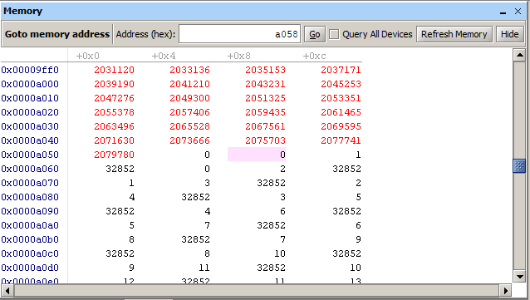

**Part III:**

**Provide your screenshot of the array in memory (single element per row, in decimal)**

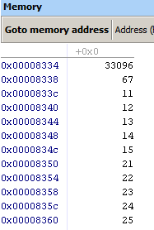

**Fill in this table with “X”s in the appropriate columns.**

|  |  |  |
| --- | --- | --- |
| **Language** | **Uses Row-Major** | **Uses Column-Major** |
| C | X |  |
| C++ | X |  |
| Fortran |  | X |
| Python | Neither | Neither |
| Mathematica | Neither | Neither |
| Pascal | X |  |
| MatLab |  | X |
| R (statistics) |  | X |

Information form: <https://en.wikipedia.org/wiki/Row-_and_column-major_order>

**Extra Credit:**

**Show your calculations of the number of instructions executed plus the estimate of the program execution time and show the comparison of that execution time with an actual run.**